**Project Design Phase-II**

**Data Flow Diagram & User Stories**

|  |  |
| --- | --- |
| Date | 31 May 2025 |
| Team ID | LTVIP2025TMID43861 |
| Project Name | Transfer Learning-Based Classification of Poultry Diseases for Enhanced Health Management |
| Maximum Marks | 4 Marks |

**Data Flow Diagrams:**

A Data Flow Diagram (DFD) is a traditional visual representation of the information flows within a system. A neat and clear DFD can depict the right amount of the system requirement graphically. It shows how data enters and leaves the system, what changes the information, and where data is stored.

**Example:**

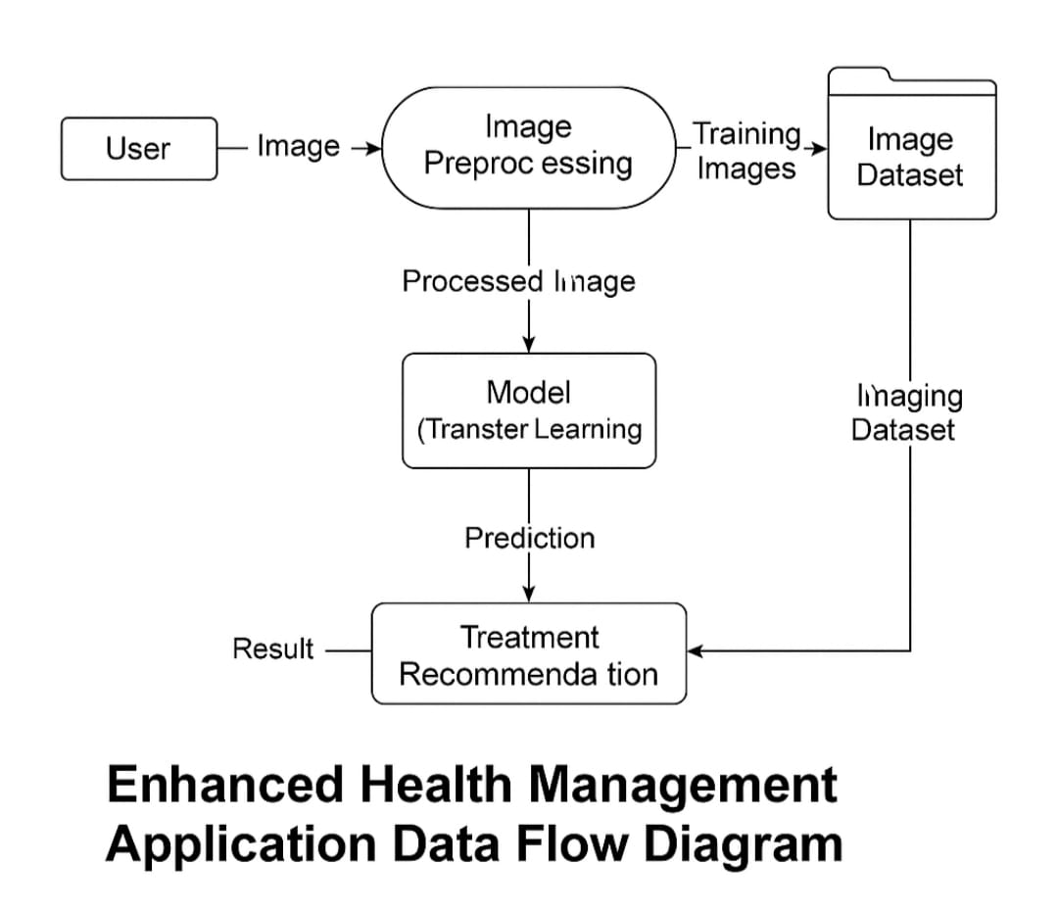

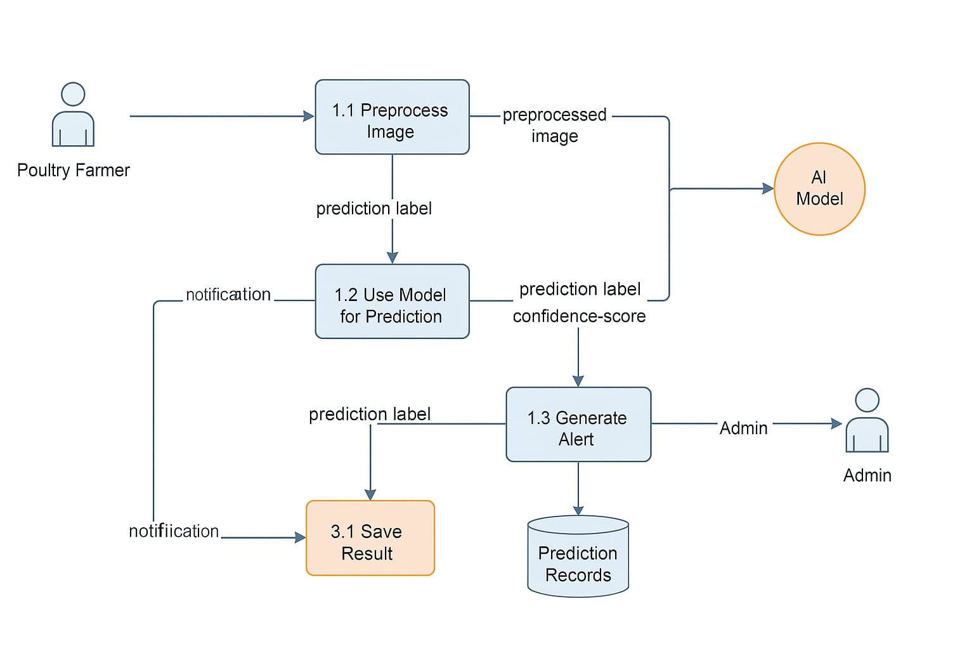

**User Stories**

Template to list all the user stories for the product.

| **User Type** | **Functional Requirement (Epic)** | **User Story Number** | **User Story / Task** | **Acceptance criteria** | **Priority** | **Release** |
| --- | --- | --- | --- | --- | --- | --- |
| Farmer(Mobile User) | Image Upload | USN-1 | As a farmer, I can upload an image of a sick bird using my mobile phone | I can successfully upload poultry images and see confirmation | High | Sprint-1 |
| Farmer(Mobile User) | Disease Classification | USN-2 | As a farmer, I want to know what disease the bird has based on the image I submitted | I get a disease prediction result (e.g., , Healthy, etc.) | High | Sprint-2 |
| Farmer(Mobile User) | Notification alert | USN-3 | As a farmer, I want to receive alerts if the bird is suffering from a dangerous disease | I receive a mobile or email notification alerting me about the condition | Medium | Sprint-2 |
| Farmer(Mobile User) | Login | USN-4 | As a farmer, I can log into the application using my phone number and password | I can successfully log in and access the app features | High | Sprint-1 |
| Farmer(Mobile User) | Disease History | USN-5 | As a farmer, I can view previously submitted images and the disease prediction history | I can access my historical predictions from a dashboard | Medium | Sprint-3 |
| Admin | Dashboard | USN-6 | As an admin, I can view reports by disease type, region, and date | I can access the admin panel and filter reports | Low | Spirit-4 |
| Developer/Admin | Model Update | USN-7 | As a developer, I can upload new poultry images with labels to improve the prediction model (transfer learning) | I can successfully upload data and trigger model retraining | Medium | Spirit-4 |